Unit 3: Linear Equations and Inequalities
Lesson 6: Solutions and Graphs & Mixed practice
Objectives:
- Students can identify the solution for linear equations.

Agenda:
- Warm Up: Independent vs dependent variables.
- Practice: Applied problems
- Discuss homework.

Vocabulary:
- Independent /Dependent.

Web Support:
Introduction: https://youtu.be/-mVHzIDN0A8
Practice: https://youtu.be/dsrJBWxwUyY

Homework: Unit 3 test in two classes next Class: Work on study guide portfolio.

Do Now
- Write an equation of a line that passes through the points (3,4) and (-6,10) in two different forms. Label each form

- Write an equation of a line that passes through the points (-3,4) and has a slope of -5.

- If point (3,k) is a point on the line above, show algebraically the value of k.

- ) What is the leading coefficient of the following polynomial: $x^{3}+5x+2=-3$

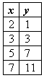
5) If x and y are defined as indicated by the accompanying table, which equation correctly represents the relationship between x and y? Show two different ways on how you arrived at your answer.
- y = x + 2
- y = 2x + 2
- y = 2x + 3
- y = 2x - 3
- Provide one example of a line that has a 0 slope and one example of a line that has an undefined slope.

Solving System of equations graphically
http://www.virtualnerd.com/algebra-2/linear-systems/graphing/solve-by-graphing/equations-solution-by-graphing
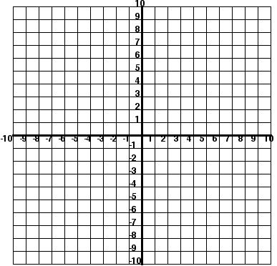
- Solve the following System of equations graphically following the steps in the video:
$$y=2x+5$$
$$y=-x+2$$

- And this
$$y=\frac{1}{3}x+5$$
$$y+x=5$$

Practice Test Unit 3: Review multiple choice for the unit Test
- Which of the following is a linear equation:  $1$. $-3x+2$ 3. $x^{3}+5x+2=-3$  - $-x+7y=12$ 4. $x^{2}+2x+4=4$ | Justify
- If (k, 4) is a point on the graph of the equation 4x + 2 y = 4, what is the value of k?
- 1 3. 6
- -1 4. -6
x | y
-2 | -9
0 | -6
2 | -3
4 | 0
- Use the table below to find the x- and y-intercepts.
- x-intercept: -6; y-intercept: 4
- x-intercept: 4 ; y-intercept: -6
- x-intercept: -6; y-intercept: -9
- x-intercept: -2; y-intercept:-6

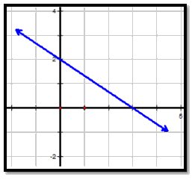
  - Which equation is represented by the graph of line L?
- $x = \frac{-2}{3}y + 2$
- $y = \frac{-2}{3} x+ 2$
- $y = 2x + \frac{-2}{3}$
- $y = \frac{-2}{3} x+ 3$
  - What is the y-intercept of the graph of the equation y = -x + 4?
- - 2. -2 3. 3 4. 4
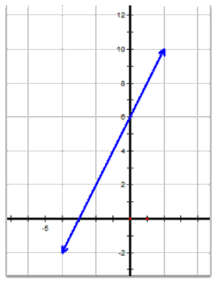
  - Use the graph below to find the x-and y-intercepts.
- x-intercept: 2; y-intercept: 6
- x-intercept: –3 ; y-intercept: 6
- x-intercept: 2; y-intercept: –3
- x-intercept: 6; y-intercept: 2

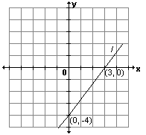
7) What is the slope of line l shown in the accompanying diagram?
- 3.
- - 4. -

8) Which graph represents the equation $Y= 3$?  - 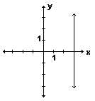 3. 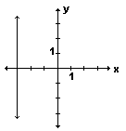  - 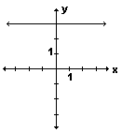 4. 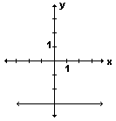 | Justify
9) Maddi bought 3 brownies for 4 dollars. which of the following statements is true:
    - The independent variable is the cost in dollars, the dependent variable is number of brownies, and the slope is $\frac{4}{3}$
    - The independent variable is the number of brownies, the dependent variable is cost in dollars, and the slope is $\frac{3}{4}$
    - The independent variable is the cost in dollars, the dependent variable is number of brownies, and the slope is $\frac{3}{4}$
    - The independent variable is the number of brownies, the dependent variable is cost in dollars, and the slope is $\frac{4}{3}$
Extended Response Questions:
10)Find the x intercept and the y-intercept of the following equation algebraically, sketch it.
$$4x-2y=16$$

  - The Sparrow town High School science department has $4,700 to spend on textbooks this year. The department needs to buy both Biology textbooks(x), which cost $97 apiece, and Chemistry textbooks(y), which cost $60 apiece.

- Write a linear inequality to describe this situation.

- What is the maximum number of biology text books that can be purchased if 20 Chemistry books are purchased?

- Can the department purchase 15 chemistry text books and 12 biology text books without being over budget?

Dig in to that portfolio……

